**Experiment Number - 1**

**Student Name:** ANIKET KUMAR **UID:** 20BCS5306

**Branch:** CSE **Section/Group:** 20BCS_WM-703 / B

**Semester:** 5th **Date of Performance:** 23rd Aug, 2022

**Subject Name:** PBLJ LAB **Subject Code:** 20CSP-321

**1. Aim/Overview of the practical:** Create an application to save the employee information using arrays.

**2. Task to be done/ Which logistics used:**

IntelliJ IDEA (IDE), JDK.

**3. Program Code:**

import java.util.Scanner;  
  
public class Project1 {  
 public static void main(String[] args) {  
  
 int empno[] = {1001,1002,1003,1004,1005,1006,1007};  
  
 String name[]={"Ashish","Sushma","Rahul","Chahat","Ranjan","Suman","Tanmay"};  
  
 String JoinDate[]={"01/04/2009","23/08/2012","12/11/2008","29/01/2013","16/07/2005","1/1/2000","12/06/2006"};  
  
 char d_code [] = {'e','c','k','r','m','e','c'};  
  
 String dept[]={"R&D","PM","Acct","front","Desk","Engg","Manufacturing","PM"};  
  
 int basic [] = {20000,30000,10000,12000,50000,23000,29000};  
 int hra [] = {8000,12000,8000,6000,20000,9000,12000};  
 int it [] = {3000,9000,1000,2000,20000,4400,10000};  
 String designation = null;  
 int da=0;  
 int salary = 0;  
 int index = -1;  
  
 Scanner sc = new Scanner(System.*in*);  
 System.*out*.print("Enter Employee ID :");  
 int emp = sc.nextInt();  
  
  
 for(int i=0;i<empno.length;i++)  
 {  
 if (empno[i]==emp)  
 {  
 index=i;  
 }  
 }  
  
 if (index==-1)  
 {  
 System.*out*.println("There is no such employee." +emp);  
 }else  
 {  
 char code;  
  
 code=d_code[index];  
  
 switch(code)  
 {  
 case'e':  
 designation="Engineer";  
 da=20000;  
 break;  
 case'c':  
 designation="Consultant";  
 da=32000;  
 break;  
 case'k':  
 designation="Clerk";  
 da=12000;  
 break;  
 case'r':  
 designation="Receptonist";  
 da=15000;  
 break;  
 case'm':  
 designation="Manager";  
 da=40000;  
 break;  
 default:  
 designation="Invalid";  
 da=0;  
 }  
 salary=basic[index]+ hra[index]+da-it[index];  
 System.*out*.println("Emp No" +" "+"Emp Name" +" "+"Department"+" "+"Designation"+" "+"Salary");  
  
 System.*out*.println(empno[index]+" "+name[index]+" "+dept[index] +" "+designation +" "+salary);  
  
 }  
  
 }  
  
}

**4. Output :**

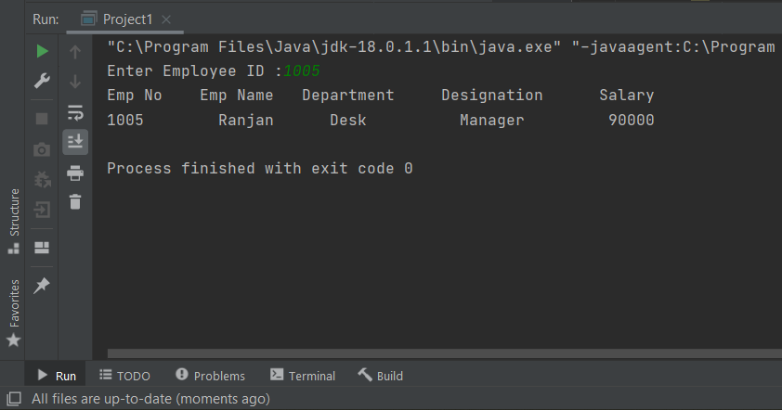

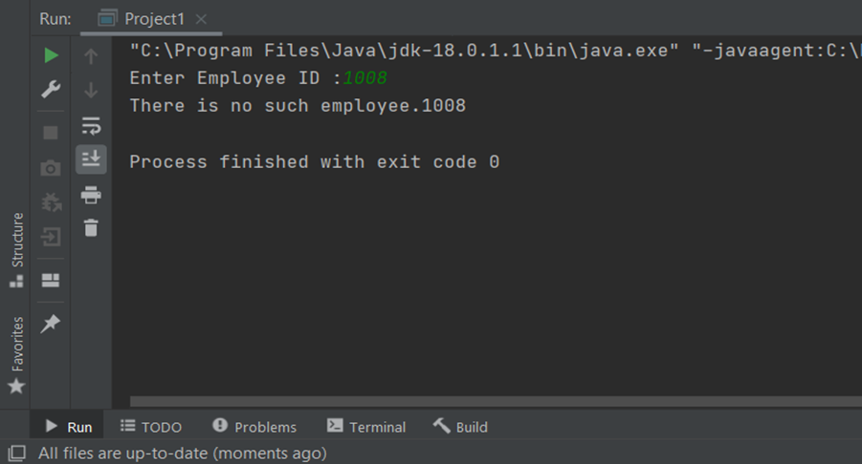

**Learning outcomes (What I have learnt):**

1. I have learnt how to write program in JAVA.
2. I have learnt how to create classes and its objects in JAVA.
3. I have learnt how to take input from user using Scanner class.
4. I have learnt how to create Array in JAVA and traverse each elements using loop.
5. I have learnt how to create an application (i.e save the employee information using arrays) in JAVA.

**Evaluation Grid (To be created as per the SOP and Assessment guidelines by the faculty):**

|  |  |  |  |
| --- | --- | --- | --- |
| Sr. No. | Parameters | Marks Obtained | Maximum Marks |
| 1. |  |  |  |
| 2. |  |  |  |
| 3. |  |  |  |
|  |  |  |  |